Avex training Guide

TBM and Maintenance General Familiarization
Power Point Supplement
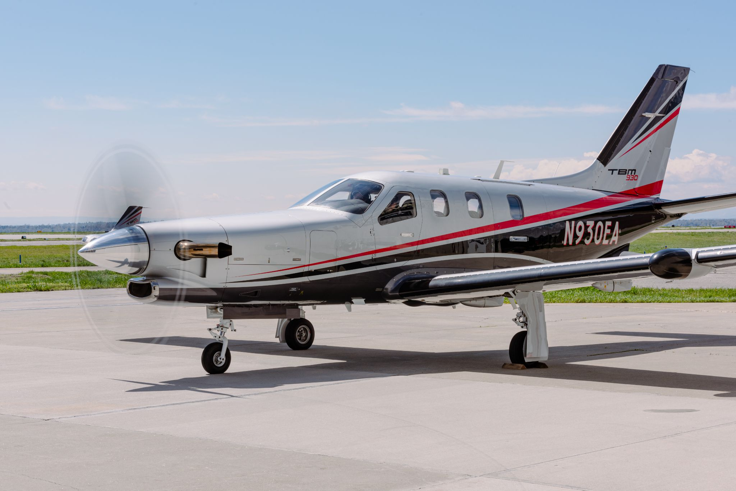

Table of contents

Introduction 6
What is Avex? 6
What is Daher? 6
What is a TBM? 6
Avex Handbook - Overview 6
Avex Handbook - Time Policy 6
ADP App 6
Avex HR 6
Job Descriptions 6
Repair station manual - overview 7
Shop Standard practices 7
Tool Control 7
Tooling Familiarization 7
Cleanliness 7
Avex Secrets and handing of trade secrets. 7
Avex standard of workmanship 7
Customer interaction 7
Professional interactions 7
Uniforms 7
Safety Module 7
Common Shop hazards 7
Slips and falls 7
PPE 7
Chemicals heavy metals, Neurological impacts 8
Hanger rash 8
Shop and TBM Electricity 8
Dirty Dozen 8
Fire plan 8
Aircraft fire 8
Aircraft propellers 8
TBM historical failures 8
TBM failure modes 8
Static wicks 8
FOD Control 8
Maintenance - 101 10
What is Maintenance and why do we do it? 10
What is Airworthiness? 10
Responsibility to customer and our business in quality & value 10
Mechanic Ethics - Workmanship 11
Mechanic Ethics - Honesty 11
Scarcity Mentality 11
Private Aviation is different from part 121/135 11
TBM - General Information 13
TBM history 13
Operational profile of TBM 13
TBM Value 13
TBM Variant, Identification based on S/N - 14
Data plate location for engine and airframe - 16
Engine offered & basic overview of PT6 engine - 17
Future of TBM + Home safe explanation - 17
What we do to TBM aircraft 18
Overview 18
Maintenance Manuals 19
TBM Manual Family 19
ATA Codes 19
Where to find Manuals 20
Accessing My TBM 20
Accessing iPad TBM App 20
Digital skills 20
The aircraft maintenance manual (AMM) 20
Nomenclature differences with translated manuals 20
TBM IPC Familiarization 21
What are TBM Service Bulletins and Service letters 21
Using CMM’s 21
STC’s Brief overview 21
Maintenance Aids 21
Repair Station manual 21
Acceptable DATA 21
Parts 22
Part removed and how we tag them - 23
Robbed parts procedure - 23
New Part Journey from receiving to installation - 23
Rotables Parts 24
Consumables 24
Paperwork for mechanics 25
FAA Requirements 25
Examples of discrepancies 25
Examples of sign offs 25
Additional paperwork 25
Paperwork custody chain 25
Aircraft work order binder 25
Discrepancies and half sheets. 25
Process for Documenting Discrepancies 26
Common discrepancy quote book 26
What is warranty work? Why are my quote times zero? 27
Overview of Half Sheets 27
Paperwork Custody 27
Keeping Track of paperwork 27
How to sign corrective actions. 27
Repair Station Maintenance Forms 28
General MX forms and checklists by Avex 28
Common abbreviations and short hand in MX signoffs 28
Training for mechanics 30
Overview of Training Flow 30
What is OJT training? And Why do we do it? 30
Teaching method during OJT 30
Mechanic training levels 30
Daher factory Initial Training 31
Recurrent training overview 31
Read and Sign (Avex Procedures Manual) 31
TBM General Practices and MX 32
Basics 32
Initial aircraft receiving inspection 32
Operation of Doors and Airstairs 32
Aircraft inventory 33
Interior Removal 33
Cowling Removal 33
Parts Tagging 33
Use of GPU 33
Powering up aircraft 33
Jacking procedure 33
Fueling 33
Servicing 33
Safety Callouts 34
Consumables 34
Post Maintenance inspection / Customer care checklist 34
TBM Routine Inspections 35
Overview of Systems by ATA 36
ATA Chapter 00-12 Overview 36
ATA Chapter 20 Overview 36
ATA Chapter 21-35 Overview. No fire protection 36
ATA Chapter 37-57 Overview 36
ATA Chapter 61 Overview 36
ATA Chapter 71-79 Overview 36
Mechanic Standard Practices 37
Task Preparation and Checklist 37
Standard Practice - Basic Repairs 37
AC 43.13-1B Overview 37
Definition of a visual inspection 37
Best Practices 38
Job time tracking accuracy 38
Paperwork 38
Preventing Re-work 38
Time Corrections 38
OFFLINE ADDITIONAL NOTES 38
Things to add 38
Items to add to training/shop manual 39

Introduction

What is Avex?

What is Daher?

Avex Handbook - Overview

Avex Handbook - Time Policy
Daily Breaks, Lunch Policy, Late Policy, Time Off requests (chain of command and approvals). Sick Time

ADP App
Checking paychecks, tax information, checking PTO time accumulation

Avex HR

Who they are, how to contact.
PTO Details and accumulations
Winter Break dates (this is not paid time off)
Bonus, what affects them, why and when do we get them
Medical benefits
Educational programs
401K
Per Deim for travel work and hotels

Job Descriptions
Mechanics Inspectors, leads, detailers, parts, Admin, Management, facilities manger, test pilot

Shop Standard practices

Tool Control

Tooling Familiarization

Cleanliness

Avex Secrets and handing of trade practices.

Avex standard of workmanship

Customer interaction

Professional interactions

Uniforms ‘

Shop Familiarization
Map of shop
Map of shop tooling
Chemical and handing + SDS
Shop care extension chords air lines
Clean up zones (where to put away battery carts, ladders, stools, step ladders)
Static Wicks
Parts table policy
Parts tagging importance
Wing Clearances
End of dat aircraft close up
GSE
Best Tugs
Vehicles
Fork lift
Inspection of equipment before use
jacks , nitrogen 02

Safety Module

Common Shop hazards

Slips and falls

PPE
Hearing
Chemical protection
Eye protection
Use of shower and fountain

Chemicals heavy metals, Neurological impacts
Cadmium

Hanger rash
Aircraft towing, hanger doors, hitting aircraft with tooling, door positions and elevator damage

Shop and TBM Electricity

Dirty Dozen

Fire plan
Evacuation, location of fire extinguishers

Aircraft fire
Aircraft with engine changes or fuel nozzle changes need to be watched by a fire observer

Aircraft propellers
You will die, its invisible, GPU starts.

TBM historical failures

TBM failure modes

Static wicks

FOD Control
In hanger and on ramp

Maintenance - 101

What is Maintenance and why do we do it?

The term maintenance is defined in 14 CFR part 1, para 1.1 as “Maintenance means inspection, overhaul, repair, preservation and the replacement of parts but excludes preventive maintenance”.

Most apparent reason for continuous aircraft maintenance is safety and help achieve airworthiness & compliance with the aviation regulators.

Note:- Example of inspection, overhaul , repair and preventive maintenance.

What is Airworthiness?
When an aircraft or one of its component parts meets its type design and is in condition for safe operation is considered airworthy.

Note :- Avex inc is Repair station certified under part 145. As a mechanic you are responsible for day to day maintenance and your lead is accountable for its fulfilment. Post all maintenance activity an Inspector will release aircraft back to service(which is technically ensuring airworthiness). Avex has a repair station manual outlining quality control procedures which we will review later in the manual section.

Responsibility to customer and our business in quality & value

Mechanic Ethics - Workmanship
Workmanship as mechanic and importance of attention to details -
Avex has the slogan “ when the details matter”. As a mechanic you have to maintain airworthiness of aircraft or its component parts, as well as work on details benefiting our customers for fast turn around by following a checklist (example - Like cleaning after your work, having presentable product for customer) 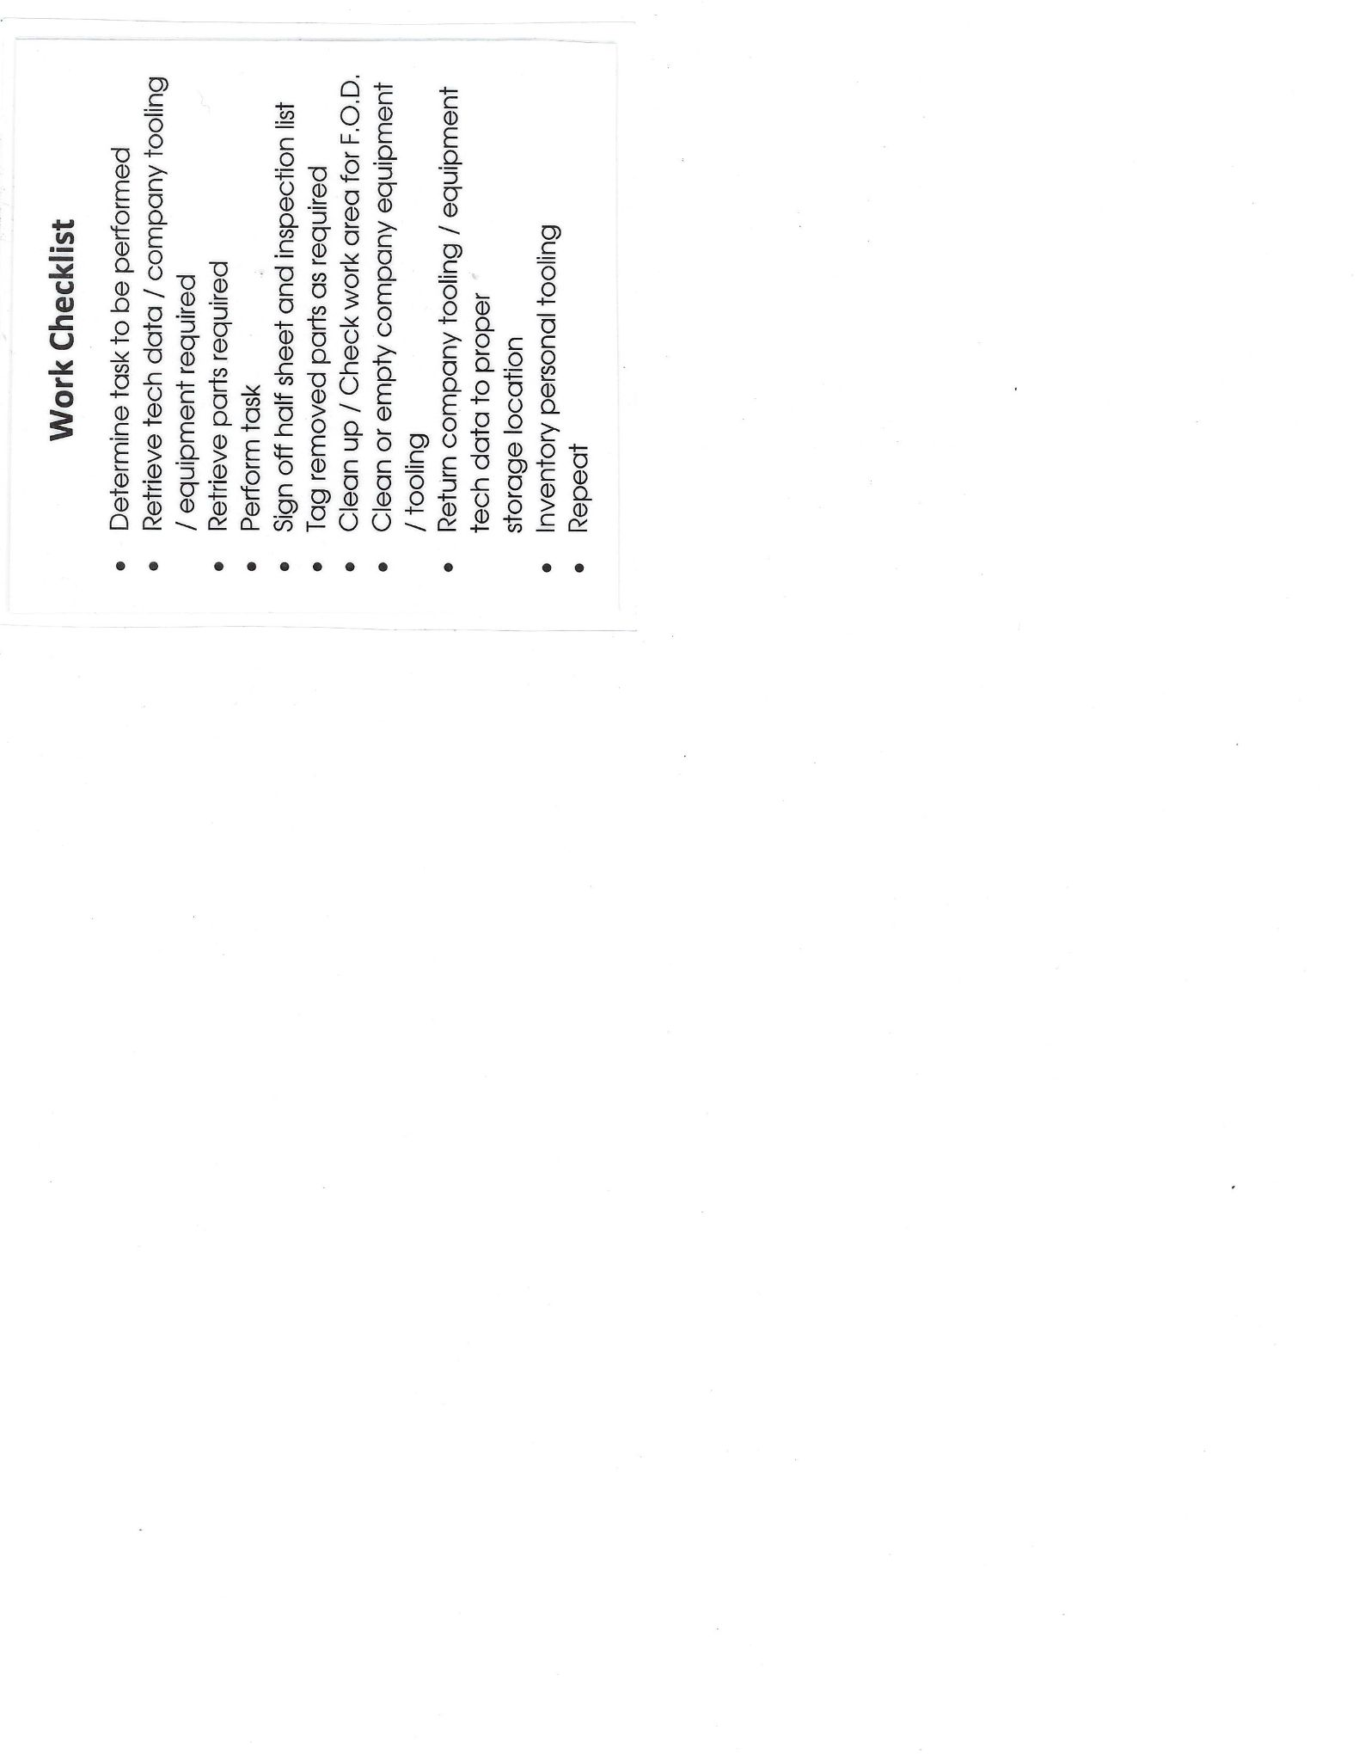

Mechanic Ethics - Honesty

A mechanic who damages an aircraft or a line service tech who runs it into a hanger door will be better off informing their boss of the mistake. Hidden mistakes will not be tolerated because it may endanger the lives of our customers and if not life threatening it damages the reputation of the shop.

Scarcity Mentality
How to democratize information at Avex
How to promote good culture
How to improve the system rather than blaming the individual

Private Aviation is different from part 121/135
How Avex and private aviation is different from part 121/135.
Part 121 (airlines) and part 135 (on demand charter) operations are different from the type of aviation that avex participates in. Avex works in part 91 aviation known as general aviation. And despite the aircraft that we work with being very fast and high altitude machines they are owned and operated by private individuals for use in pleasure and business. Very few are operated as a part 135 charter and non are operated in the 121 world.

This means that our business is devoted to our customers rather than timely turnarounds and fleet reliability statistics. We serve the owners of the aircraft and have a responsibility to maintain not only the life saving mechanical systems of the aircraft but the appearance and aesthetic of the plane.

TBM - General Information

TBM history
The SOCATA TBM (now Daher TBM) is a family of high-performance single-engine turboprop business and utility light aircraft manufactured by Daher. It was originally collaboratively developed between the American Mooney Airplane Company and French light aircraft manufacturer SOCATA.
The design of the TBM family originates from the Mooney 301, a comparatively low-powered and smaller prototype Mooney developed in the early 1980s. Following Mooney's acquisition by French owners, Mooney and SOCATA started a joint venture for the purpose of developing and manufacturing a new, enlarged turboprop design, which was designated as the TBM 700.
In 1990 the company certified with the FAA and French DGAC (EASA) the first, fully-pressurized, single-engine, turboprop aircraft in the world, the TBM 700A. The original model (TBM 700A) was followed by the B model, featuring a large access door to allow easy passenger and baggage loading, as well as newly designed seats to improve comfort.

Operational profile of TBM
TBM has a maximum cruise speed of 300 Knots to 330 Knots with a full fuel IFR range of more than 1400 to 1730 nautical miles and ceiling height of 30,000 ft to 31,000 ft for TBM 700 A & B and for other variants respectively.
Cabin capacity
Useful load

TBM Value
- TBM Value - TBM 940 -$4.13 Million
- Used Aircraft value range
- Engine value range ASK BOB
- Some of our least expensive aircraft are work in the neighborhood of 800K to 1.4M Some of out most expensive aircraft retail for 4.575M which is 700k more than buying two Bugatti Veyron’s

TBM Variant, Identification based on S/N -
TBM 700 A is basic aircraft, TBM B,C1,C2 and N are defined as variants. TBM 850 is marketing name of TBM 700 N. In March 2014, an aerodynamically refined version of the TBM 700N, marketed as the TBM 900, was made available. Currently we have TBM 910, TBM 930 and TBM 940 as other variants.

Based on S/N-
TBM A - 1 to 123 S/N
TBM B - 124 to 243 S/N
TBM C1 & C2 - 244 to 345 S/N
Note - TBM 700 – 324 built between 1990 and 2005

TBM 850 - 346 to 433 S/N
TBM 850 glass cockpit - 434 to 999 S/N

Note:- TBM 850 – 338 built between 2006 and 2013

TBM 900/930 - 1000 to 1169 (TBM 930 - from 1111)
TBM 910 - from 1170

Note:- TBM 900/910/930 – 217 built:
TBM 900 – 114 built between 2014 and 2016
TBM 910 – 29 built since 2017
TBM 930 – 74 built since 2016.

TBM 940 - S/N

-TBM TYPES, NOTES FROM WIKIPEDIA-
TBM 700A
Initial production version with one Pratt & Whitney Canada PT6A-64 turboprop engine.
TBM 700B
Variant with wide entrance door, increased maximum zero fuel weight and other improvements.
TBM 700C1
Improved version with rear unpressurised cargo compartment, reinforced structure, new air conditioning system and other improvements.
TBM 700C2
C1 with increased maximum takeoff weight.
TBM 700N
Initial production name of the TBM 850.
TBM 850
Higher-performance version fitted with a Pratt & Whitney Canada PT6A-66D engine, rated at 850 hp in flight (700 hp at take-off).
TBM 850 G1000
TBM 850 with a G1000 Integrated Flight Deck and a fuel tank extension modification.
TBM 850 Elite
Updated version of the TBM 850, including four cabin seats in a forward-facing configuration, allowing for an increased cargo area aft of the cabin.^{[16]}
TBM 900
Improved version of the TBM 850 with various aerodynamic refinements, including winglets and a redesigned induction system.^{[17]} Maximum cruise speed increased to 330 kn (611 km/h) at FL310. Range of 1,730 nmi (3,204 km)—with 45-minute standard IFR reserves—at 252 kn (466.7 km/h) and 37 gph (140 l/h), or 1,585 nmi (2,935.42 km) at 290 kn (537 km/h).^{[7]} The 40% larger intake frees up airflow, giving an 80 hp (60 kW) boost for the same fuel flow and shortening the take-off roll by 20%.^{[18]} The previously optional Hartzell five-blade carbon fiber propeller is now standard, increasing performance and decreasing cabin noise.
TBM 910
New version introduced in April 2017, with the upgraded avionics suite Garmin G1000 NXi.^{[19]}
TBM 930
introduced in April 2016, with upgraded interior and avionics, including the Garmin G3000 touchscreen avionics suite. The TBM 930 is offered alongside the 900 and has not replaced it in the line-up.^{[20][21]}
TBM 940
introduced in March 2019, with autothrottle and automatic deicing, priced at $4.13 million.^{[10]} It was certified by EBACE show in May.^{[22]} On a standard day, the TBM 940 climbs to FL280 in 17min ½, within 64nmi (119km), for a 7,600ft cabin altitude with the 6.2 psi (0.43 bar) pressurisation, fuel flow is 59 USgal (223 litres) per h at maximum cruise power, reaching 304 kn (563 km/h) at ISA +13°C instead of 326 kn (604 km/h) on a standard day.^{[18]}
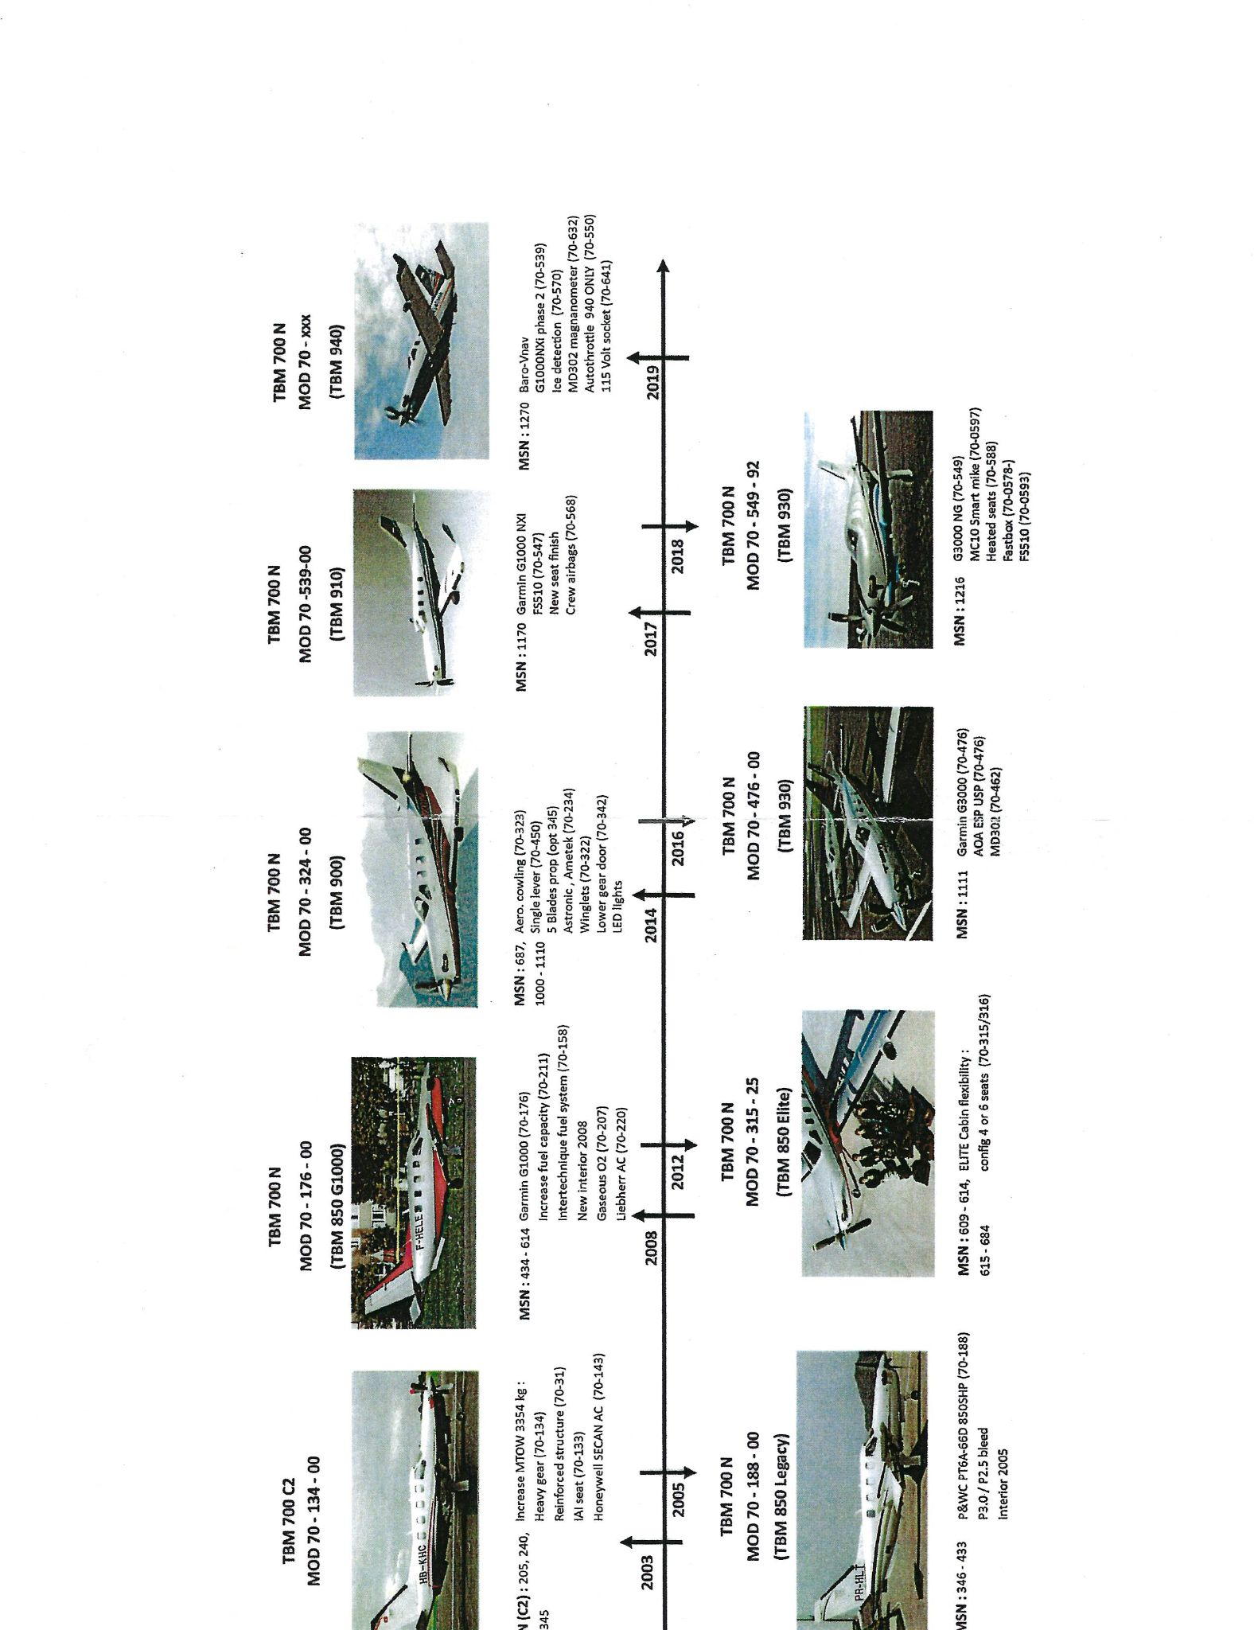

Data plate location for engine and airframe -
- Insert Photo of locations for data tags

Engine offered & basic overview of PT6 engine -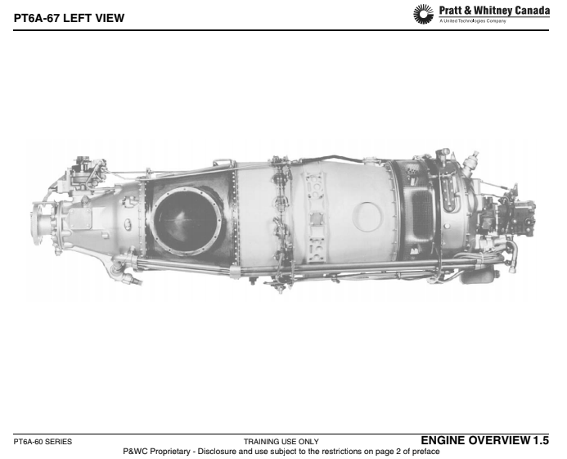
TBM is fitted with PWC PT6 engine. TBM 700 A,B & C are fitted with PWC PT6A-64 and PWC PT6-66D is installed from TBM 700 N.

Aircraft | Engine | Max Takeoff Power | Max Continuous Power
TBM A,B & C | PWC PT6A-64 | 700 SHP | 700 SHP
From TBM 700 N | PWC PT6A-66D | 700 SHP | 850 SHP

Future of TBM + Home safe explanation -
- What is home safe
- What is the kodiak?

What we do to TBM aircraft

Overview
Avex as a distribution company & repair station, we deal with buy & sell of TBM (also pre buys), inspection (including 100hr, recurring A,B,C + annual inspection ),schedule & unscheduled maintenance,Upgrades & modifications (following SB & AD) and AOG for our customers.We also have an avionics shop and Landing gear actuator shop (only in Camarillo,CA).
Pre buys

Note :- Avex buys 6 TBM each year in advance. (ASK BOB)

Maintenance Manuals

TBM Manual Family
The TBM is maintained by a variety of manuals.
The aircraft is divided into Airframe, Powerplant, propeller, components. The family of manuals for the airframe are:
- AMM - Aircraft Maintenance Manual
- WM - Wiring Manual
- IPC - Illustrated Parts Catalog
- POH - Pilots operating handbook
- (No SRM - Structural repair manual offered by Daher)
The powerplant manual family is:
- (EMM) - P&WC MM - Pratt and whitney Canada Engine Maintenance Manual
- Engine IPC - Engine Illustrated parts catalogue
The propeller with various manufacturers has
- Propeller owners handbook
- Propeller repair manual
And components with different manufacturer than that of daher commonly have their own manuals.
- CMM - Component Maintenance manuals

ATA Codes
These manuals Primarily use a Code standardized by the Air Transport Association (ATA). This system consists of 100 codes to categorize aircraft maintenance and systems. Not all the codes are used on a TBM because we don't have all the comoponets of other aircraft EX: we don't have and APU auxiliary power unit so we don't have a chapter 49 in our manuals.

Here is an example of ATA codes used on TBM’s
INSERT ATA CODE CHEAT SHEET FOR TBM

Where to find Manuals
- Digital access
  - Computer
  - iPad
- Physical Access
  - Manual library
Checking revision status of printed materials
- You must use the most current information. These manuals are updated frequently
- Examples

Accessing My TBM
- Login pages and navigation of web portal.
- Find AMM, IPC, SL, SB, and CMM.
- Guide photos

Accessing iPad TBM App
- Login and navigation
- Find AMM, IPC
- Verifying manual currency
- Guide photos

Digital skills
- Navigating PDF’s and their bookmarks
- How to print from your iPad
- Guide photos

The aircraft maintenance manual (AMM)
- Daher AMM Familiarization and Reading Page number codes (Ex: 501, 601)
Photo of page

Nomenclature differences with translated manuals
Daher manuals were written by French speakers and have some variations of language in the technical writing.

Here are some examples: _________________________

Fins= aft strakes area 300
Windows = windows and doors and inspection plates

TBM IPC Familiarization
- Part applicability determination (like usable on codes but applicability in bottom corner)
- Determining MOD Status

What are TBM Service Bulletins and Service letters
- What are they?
- How are they issued?
- Common examples.

Using CMM’s
- Where are they
- Common examples
  - Zodiak Aerospace Deice Boots
  - Goodrich Brakes

STC’s Brief overview
- STC - Supplemental type Certificates modifies the type design of an originally certified aircraft
- They have ICA’s - Instructions for continued airworthiness that must be complied with

Maintenance Aids
- Avex developed guides and checklists
- List of guides
- List of checklists
- Not approved data (for Reference only)

Repair Station manual
- Where to get it and what its useful for

Acceptable DATA
How to use AC 43.13-1B
- You cannot use AC 43.13-1B for repairs to a pressurised area.
- Can be used for standard repairs in lieu of a manual reference and is acceptable only for minor repairs.

Parts

Part removed and how we tag them -
Tagging is a term used in US aviation to indicate a part is serviceable and airworthy as evaluated by an FAA certified repair station. Any component or part removed from aircraft must be tagged for appropriate identification and tracking.
- White tag - Use to identify any removed component and to facilitate other maintenance or access.
- Yellow tag - Use on component which is serviceable and airworthy.
- Green tag - Use on component which is not airworthy but is repairable
- Red tag - Use on component which is scrap or unusable.

Note:- Tagging & identification of parts process is defined in the repair station quality control manual (Para 9.1.3 pg 9-2).

- How tags are filled, example -
- Who can certify Yellow tag - Shop foreman or chief inspector
- Who can destroy red tag - Shop foreman or chief inspector

Robbed parts procedure -
- Verify avex’s policy and then make procedure

New Part Journey from receiving to installation -
A new part can be ordered from avex workshop/corridor using IPC of TBM or PWC. Once a new part requisition is created, the part team will issue parts from Avex store, if available or order from Daher/ other vendors. Each part has FAA form 8130-3 (approved airworthiness tag), ensuring traceability and easing the movement of products and articles throughout the aviation system.

- Example of 8130-3 & its overview (photo)
- Receiving inspection from parts clerk
  - checklist
- Return of unused parts
- What parts need approval from an admin before ordering in the system -

Rotables Parts
Example where you should use and not use a rotable.

Consumables
- Ordering shop consumables
- Proper application of consumables
- Stewardship of consumable

Paperwork for mechanics

FAA Requirements

Examples of discrepancies
How to fill out a discrepancy sheet
How long things take
How to find part numbers

Examples of sign offs
R&R
Inspection
When to require an ops check, rigging check, leak check

Additional paperwork
Avex forms and

Paperwork custody chain

Aircraft work order binder
- Who complies it
- How to use it, how it is organized
- Where is it kept
- Avionics also has binder
- Where to put traceability paperwork 8130-3 and signed off half sheets

Discrepancies and half sheets.
- When a deviation from type design (eg damage) exists on a plane the mechanic will write up a discrepancy on a avex discrepancy log. This log has a standard format
  - Photo of filled out discrepancy log
- Discrepancy and corrective action flow.
  - After a discrepancy has been reviewed by a lead mechanic and parts are looked up it will be submitted to the Admin department who will ask the customer to approve or deny the discrepancy. If approved a half sheet will be generated and issued under the work order to the aircraft. Then the mechanic can perform the task then document and certify the maintenance performed by filling out the corrective action block of the half sheet and signing the certification block. The work must then be inspected by an Repair station authorized inspector with a inspection stamp and once complete the half sheet will be submitted to the quality control department (Q/C) who will review the corrective action for errors and if none are found they will generate a logbook entry for the aircraft out of the half sheet.
  - Make flow diagram

Process for Documenting Discrepancies
- Photo of filled out discrepancy and labels of its various components
- When documenting discrepancies you must determine whether the discrepancy is mandatory or recommended. Mandatory discrepancies affect the airworthiness of the aircraft and have to be corrected before the next flight of the aircraft. Recommended discrepancies are optional repairs or cosmetic damage that can be corrected if the owner wants to.
- Each discrepancy will need a estimated amount of time to complete given. This time is passed on directly to the customer and should be accurate as possible but erring on the side of over estimation to set correct expectations with customers.
- If there is a part associated with the discrepancy your lead will look up the part unless he asks you to enter the part information. It is useful to include IPC references for cross checking parts - especially Rotable parts.
- When making a Discrepancy write up please be specific about location and detailed about the problem or damage encountered. If there are any tolerances or dimensions that have been exceeded on the aircraft include the manual reference and accapbtle tolerance for comparison.
  - These write ups are transferred to the Admin department and they do not have the same technical background. Sometimes the Admin department is unable to interpret why you have written up a discrepancy to a customer. So it is important to be detailed in your description of the discrepancy and why it constitutes a deviation from airworthiness.

Common discrepancy quote book
---this applies only if we make this book---
- There is a common discrepancy quote book developed to help mechanics and leads accurately quote the time required to correct discrepancies. Refer to this book to get a general sense of the time expected for a trained and experienced mechanic to perform the task.

What is warranty work? Why are my quote times zero?
Newer aircraft in the TBM fleet are commonly covered under a manufacturer warranty program. When quoting jobs on warranty aircraft those aircraft must have their quotes submitted to the Daher warranty department. This negotiation of approved time for specific discrepancies happens between Avex and Daher, so when discrepancies are returned to Avex they may be underquoted with a lower amount of time than was requested initially. Most times this will result in the mechanic going over the new lower quoted hours amount which is unavoidable.

Overview of Half Sheets
- Photo of half sheet and components
- Guide to filling out half sheet

Paperwork Custody
Illustration of paperwork custody chain, (start from generation, end with logbook entry)

Keeping Track of paperwork
Why is it important to keep track of paperwork
- Filling out paperwork after a job is complete
- Reviewing paperwork before submitting
- Ensuring paperwork is not lost
- Short Signing

How to sign corrective actions.
- FAA requirements
  - Description of work performed, status of part (new, overhauled, Inspected Serviceable, rebuilt), Name, Certificate, date. (operational test, leak check, rigging check)
  - FAA FAR Ref
- Using the parts boxes
- How to be concise
- Use of common acronyms
- Short Signing requirements.
  - Importance of short signing discipline
- Example of half sheet sign offs
  - Changing a tire
  - Removing and replacing a light
  - Signing off an inspection with discrepancies
- Correcting errors. Inspectors and Q/A will review your paperwork. They will return your paperwork if it contains errors. It is important to be active in the process and to try and correct errors yourself and not to rely on the inspection system to correct you.
- Do you need a 6 digit ATA code for a sign off? No but it's an industry standard you need a good statement of work performed and approved data for that corrective action.

Repair Station Maintenance Forms
- Make list of forms that are written into the repair station manual

General MX forms and checklists by Avex
- Make list of forms used by Avex but not in repair station listing

Common abbreviations and short hand in MX signoffs
- Introduce acceptable abbreviations and their definitions
  - MLG - Main landing gear
  - NLG - Nose landing gear
  - RH - Right hand
  - LH - Left Hand
  - MX - Maintenance
  - FWD - Forward
  - AFT - AFT
  - INBD - Inboard
  - OUTBD - Outboard
  - MM - Maintenance manual
  - AMM - Aircraft Maintenance Manual
  - CMM - Component Maintenance Manual
  - WM - Wiring Manual
  - IPC - Illustrated parts Catalogue
  - POH - Pilots operating handbook
  - IAW - In Accordance with
  - REF - In Reference to
  - STC - Supplemental type certificate
  - ICA - Instructions for Continued airworthiness
  - P/N - Part Number
  - S/N - Serial Number

Training for mechanics

Overview of Training Flow
Insert training flow diagram from Lucid chart

What is OJT training? And Why do we do it?
On-the-job training, also known as OJT, is a hands-on method of teaching the skills, knowledge, and competencies needed for employees to perform a specific job within the workplace. Training takes place within the employee's normal job environment and may occur as he or she performs their actual work.
Benefits of Job Training
- Increased efficiencies in processes, resulting in financial gain.
- Reduced employee turnover.
- Increased job satisfaction and morale among employees.

Teaching method during OJT
Students must complete the first 3 steps before signoff minimum.
- Maintenance action/inspection shown by lead or senior mechanic
- Maintenance action/inspection done along with lead or senior mechanic
- Maintenance action/inspection performed solely by New mechanic and inspected by instructor.
- Additional signoffs if necessary
- Signed off for solo work
- Example of OJT log sheet.
- Who can sign OJT log sheet-

Mechanic training levels
- Level 1 (define goals of training levels) Initial 6-12 months shop competency
- Level 2 Trained and billable on all common shop inspections and repairs
- Level 3 Trained and billable on most advanced repairs has intermediate T/S skills
- Level 4 Advanced T/S knowledge about rare repairs and inspections
- Specialization Specific specialization skills

Daher factory Initial Training
Once every year, Avex organises Daher factory initial training for new mechanics. Previously trained mechanics take advanced courses to sharpen their T/S skills and general knowledge base.
- What to expect

Recurrent training overview
- Avex recurrent training
  - Design requirements
- Daher factory recurrent training - every year.
  - Timing and requirements
- FAA Fast training description
  - requirements
- FAA Diamond program description
  - Requirements
Insert recurrent training flow from lucid chart

Read and Sign (Avex Procedures Manual)
- Description
- Purpose
- How entries are made

TBM General Practices and MX

Basics
- Aircraft directions are always taken from the view of a pilot when they are sitting in the pilots seat.
  - Insert graphic of FWD AFT OUTBD and INBD.
  - Introduce aircraft stations and water lines.
  - Examples of writing up damage on wings, or fuselage
- Identification of basic aircraft parts
  - Wings
  - Ailerons
  - Flaps
  - Rudder
  - Elevator
  - Trim
  - Horizontal and vertical stabilizers
  - Antennas
  - Drains
  - Engine
  - Propeller
  - Airstair door
  - Pilot door

Initial aircraft receiving inspection
- Awareness and training for signs of trouble
  - Look for
  - Hanger rash
  - Leaks
  - Borescope
  - Oil Sample

Operation of Doors and Airstairs
- How to open Doors
- How to open Airstairs

Aircraft inventory
- Checklist use

Interior Removal
- Parts tracking

Cowling Removal
Removal of chin Cowl, y duct, bottom panels, battery removal, spinner and shims

Parts Tagging
Table and shelf tags. White, green, yellow, red.
Disciple and importance of not loosing parts

Use of GPU
- Big GPU
  - Wall mounted switch
  - Understanding the dials
  - What it can be used for
    - GPU starts
    - Engine Motoring

- Small GPU
  - What it can be used for

Powering up aircraft

Jacking procedure

Fueling
- How to defuel an aircraft,
  - Safety concerns,
  - Re-fueling
  - Using the fuel log

Servicing
- O2 servicing
- Oil Servicing
- Tire pressure
- Brake fluid

Safety Callouts
- Gear swings, flap extension, propeller motoring, application of power, movement of flight controls.

Consumables
- When using do not be wasteful
- Request items when they are low. It is the technicians responsibility to request more free stock or consumable items when they are low
- Consumable items are found in the free stock area, paint and chemical cabinets, and from the detailers storage lockers.

Post Maintenance inspection / Customer care checklist

TBM Routine Inspections
How to use the main inspection checklist
- Using the main inspection checklist is straightforward. There is a description of the inspection of MX action that is required to be performed and
Different types of inspections
Phase and annual Inspection modules OJT
Opening of aircraft-
- Cowlings, 210 doors, propeller spinner, battery box and battery. 300 area,
Areas
Area 100
Area 200
Area 210
Area 300
Area 500/600
Area 700
Lubrication
Specials

Overview of Systems by ATA

ATA Chapter 00-12 Overview

ATA Chapter 20 Overview

ATA Chapter 21-35 Overview. No fire protection

ATA Chapter 37-57 Overview

ATA Chapter 61 Overview

ATA Chapter 71-79 Overview

Mechanic Standard Practices

Task Preparation and Checklist

Standard Practice - Basic Repairs

AC 43.13-1B Overview
Advisory Circular 43.13-1B is used when there is no other manufacturer instructions. This AC is to be used only in non-pressurised areas of aircraft.

Definition of a visual inspection
Insert written defenition of Visusal inspection and find inspections AC
Insert and make familiar the Corrosion AC

Best Practices

Job time tracking accuracy
- Avoiding borrowing time. (correction we can borrow time)
- Write ups and steps in corridor
- Why

Paperwork
Chain of custody for paperwork

Preventing Re-work
Planning work routines to not overlap inspections and other MX tasks

Time Corrections
How to make a time correction
Who to send it to

OFFLINE ADDITIONAL NOTES

Things to add
- Add to specializations
  - De-ice Boot Repair
  - Engine work (CT, PT, and Engine changes)
  - Sheet Metal
  - AC system Diagnosis and Repair.
    - All aircraft models
  - Troubleshooting
    - Electrical
    - Airframe
    - Engine
- Battery charging and reconditioning written procedure
  - Capacity testing procedure
- Lead manual additions
  - Items to be done at a beginning of an inspection
    - Battery capacity testing
    - Oil samples
    - Parts sent out for overhaul

Items to add to training/shop manual
- Index of items in manual
  - Section of training guides
    - Battery capacity test, and reconditioning procedure
    - Servicing of propellers
    - Engine cleaning
    - 10 year landing gear inspections
    - Paperwork guide
    - Robbed parts procedure
    - Avex standard shop practices
      - Brake wear inspections and recommended versus mandatory replacement limits
      - P3 perry seal acceptance or rejection
      - Torque tube inspection on rudder area 300
      - Oil servicing standard between 2-3
      - Torque stripe/seal on flaps and other surfaces
        - Make a map
      - Decal condition
      - Replacement of A/C compressor we will also replace both secondary generator and compressor belts due. This is because these belts may under closer inspection be bad when removed and they are so cheap its prudent to replace them every time a compressor is removed and replaced.
  - De-ice boot repair
  - N number vinyl changes
  - Forklift operations
  - Safety - ear protection
Safety seminar
Oil leaks in engine bay active leaks versus over serving or spillage
Torque striping - safety wiring, small squawks discretion.
Servicing application of grease. Thin not thick grease attracts dirt
Aero shell 7 on engine controls
Inspection of wheel bearing and corrosion

Photos of acceptable versus rejection.

Make a guide for Identification of AC system types, Secan, Keith, ECT

